Application

From :
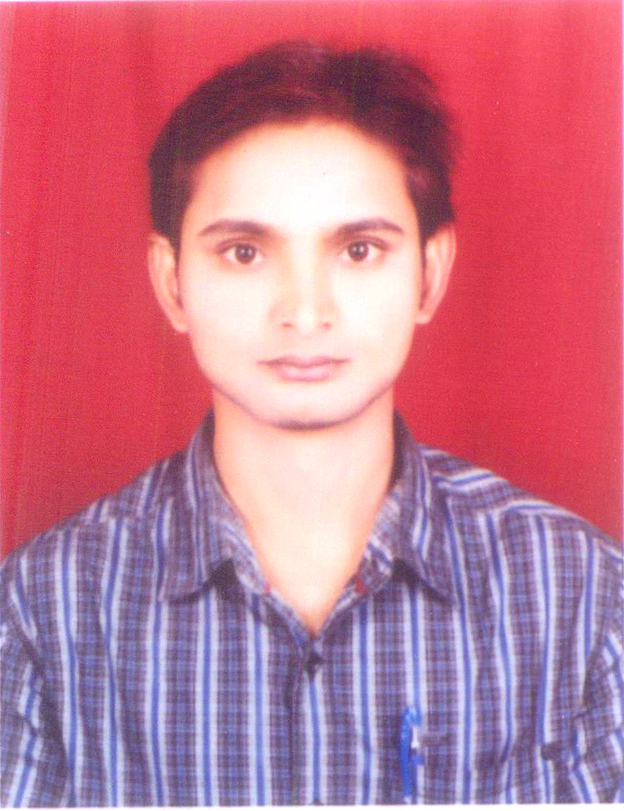
Sudhir Kumar Yadav
Vill. – Mathuali,
Post – Salemgadh,
P.S. – Tarayasujan,
Dist. : Kushnagar,
Pin Code – 274409
State – U.P.
Mob. No. :+91 9709233915, +918881147987
+966501550865 / +966571018782,
Skype I'd: sudhirkumaryadav26 E-mail id : sudhirky1983@yahoo.com
sudhirkumaryadav26@gmail.com
To,

The HR Manager/General Manager
………………………………………………………..
………………………………………………………...

Sub. : Application for the Post of Hot Metal Liquid, Handling E.O.T. Crane Operator S.M.S. (L.R.F.) Caster, D.I.S.P.M.B.F. ) S.M.S.L.R.F.

Respected Sir,

I have come to know from reliable source that, there is some vacancy for above mentioned post in your organization. I would like to offer as a candidate of the same. I enclose here with my bio-data and education qualification for the above post and request you to please look into the matter and give me opportunity to serve under your kind and sympathetic consideration.

I hope that will consider my application and give me a chance to prove my best ability.
Thanking you in anticipation your kindly reply soon.

Yours Faithfully

(SUDHIR KUMAR YADAV)

To,

The HR Manager/General Manager
…………………………………………………………
…………………………………………………………

RESUME

Post : Hot Metal Liquid, Handling, E.O.T.
Crane Operator S.M.S. (L.R.F.) Caster
D.I.S.P.M.B.F. (S.M.S. L.R.F.)
Name : SUDHIAR KUMAR YADAV
Father’s Name : Manager Yadav
Date of Birth : 07/02/1983
Permanent Address : Vill. – Mathuali,
Post – Salemgadh,
P.S. – Tarayasujan,
Dist. : Kushnagar,
Pin Code – 274409
State – U.P.
Mobile No. : +919709233915, +918881147987
(Saudi Arabia) Mobile Number
+966501550865,+966571018782
E-mail id : sudhirky1983@yahoo.com, sudhirkumaryadav26@gmail.com
Skype I'd: sudhirkumaryadav26
Communication Address : Saudi Arabia
Passport No. : K1382138, Expiry Date : 29-04-2022
Sex : Male
Nationality : Indian
Religion : Hindu
Mother Tongue : Hindi & English, Bhojpuri, Arabic language
Marital Status : Married

EDUCATIONAL QUALIFICATION:

Name of Exam. | Name of Board | Class | Subject
High School Passed | U.P. Board, 1999 | First Class | Science
Intermediate | U.P. Board 2001 | First Class | Science

WORK EXPERIENCE :

- Worked at Facor Steel Division (AN ISO 9002 COMPANY) Vidhabha Iron & Steel Corporation Ltd. C/o Entceh Govt. Licence Electrical Contractor Pvt. Ltd. 45, B.A.M.I.D.C. Central Road Nagpur, from 8th January 2002 to 10/08/2005 as a E.O.T. Crane Operator(50 Ton)
- Worked at M/s Jindal Saw Ltd., (An ISO 9002 Company) Vill. – Samaghogha, Taluka Mundra, Dist. : Kutch, Gujrat from 18th August 2005 to 20th December 2007 as a E.O.T. Crane Operator(63 Ton) D I S P, S D I P,
- Worked at M/s Jay Balaji Industries Ltd., Unit-III, Vill. – Banskopa, Post – Rajbandh, Durgapur – 713212 from 31st December 2007 to 25/07/2008.(120Ton & 63 Ton)M B F, S M S
- Worked in M/s Usha Martin Ltd. (Usha Alloys & Steel Division) Vill. – Adityapur, Industrial Area Gamharia, Dist. : Seraikella-Kharsawan, Jamshedpur, Jharkhand – 832108 form 8th Aug 2008 to 15th Feb 2013 as a E.O.T. Crane Operator(150Ton) S M S, L. R. F
- Presently working in NATIONAL STEEL & ARAB STEEL CO.LTD. (ALTUWAIRQI HOLDING COMPANY)subsidiary of All Ittefaq Steel Products CO. 2nd industrial city, p.o. Box 7600 Dist. Dammam31472 ,Saudi Arabia. 26.2.2013 to till date, as EOT crane operator(100,Ton, & 180Ton & 250 ,& 260 Ton)S M S, L R F

All Company Employees.

Job Description:

- Scrap charging basket in Furnace
- Hot electrode changing.
- Electrode preparation.
- Electrode fixing in EAF & LF.
- Liquid Metal handling from EAF – LF – VOD & AOD to Caster.
- Shell change jobs.
- Alloy material shifting & addition.
- Caster Seq. break activities handling.

Summary:

I have been working with cranes since 2002, accounting to total experience of 16 + Years. With the job descriptions mentioned above I have been part of all the job activities related to Steel melt & cast shop.

Thanking You,
(SUDHIR KUMAR YADAV)

